The First Six Months Decide: A Data-Driven Retention Strategy for an Auto Insurer

Final Stage 1 — Data Analytics Competition

Team DataWizards
Member One — Member Two
University Name
2026

(Example article built on a public Kaggle dataset; adapt to the competition case)

Executive Summary
An auto insurer loses 11.5% of its customers, and with them about USD 17.50 million of annual premium. Using records of 160,000 policyholders, we combined statistical driver analysis, survival analysis, an interpretable logistic regression and a cross-validated gradient-boosting ensemble to answer who leaves, when, and what the company should do about it. Churn is overwhelmingly an early-tenure problem: customers in their first six months churn at 49.2%, 4.3 times the average, and the churn hazard peaks between day 90 and day 180 of the relationship. After controlling for demographics, being in the first six months multiplies the odds of churning by 12.6. Younger customers (25–34) are a secondary risk group, while socio-economic variables such as income, home value or premium level add little. Our final model (ROC-AUC 0.706, 95% CI 0.701–0.710) concentrates risk sharply: the top 10% of scored customers churn at 50.0% and the top 20% contain 52% of all churners. A retention campaign aimed at the 10% of customers with the highest expected loss is estimated to return a net USD 601 thousand (ROI 1.5×), whereas random targeting would lose money. We recommend (1) a structured 180-day onboarding programme with a renewal-readiness touchpoint before day 90, (2) a monthly early-warning score that routes 'Priority Save' customers to retention staff, and (3) life-stage tailored engagement for young customers, each validated through a controlled pilot.

1. Introduction
Personal auto insurance is a highly contestable market: products are standardised, prices are easy to compare and switching costs are low. For an insurer, every lost customer means lost future premium and unrecovered acquisition cost, and the economics of retention are well documented — Reichheld and Sasser (1990) showed that reducing defections by 5% raised profits by 25%–85% across service industries. In insurance, research links lapse and non-renewal to contract age, price changes at renewal and service experience (Brockett et al., 2008; Eling & Kiesenbauer, 2014; Guelman & Guillén, 2014). Recent work also stresses two practical points: churn models should be judged by the profit of the campaigns they enable rather than by accuracy alone (Verbeke et al., 2012), and the customers most likely to leave are not necessarily those most likely to respond to an intervention (Ascarza, 2018).
This study analyses 160,000 customer records of a Texas auto insurer (public data) to answer four questions. RQ1: Which customer characteristics are associated with churn, and how strongly after controlling for the others? RQ2: When in the customer lifecycle is churn risk highest? RQ3: How accurately can churn be predicted, and which customers should be prioritised? RQ4: Which retention actions offer the highest expected value?

2. Data and Methodology

2.1 Data and preparation
The training data contain 160,000 customers (with a further 40,000 customers to be scored) and 21 variables: annual premium, tenure in days, customer start date, age, location (city, county, coordinates), household income, home market value, home ownership, marital status, children, education, credit standing and length of residence. The churn rate is 11.5%. Preparation was automated and audited: home market value, stored as text ranges such as '50000 - 74999', was converted to range midpoints; dates were parsed; a constant column (state) and two identifiers were excluded; and geographic coordinates were missing for 15% of customers, which was retained as information rather than imputed away. Most importantly, the account suspension date is recorded only for customers who left; it is a post-event variable that would leak the outcome (its presence alone predicts churn perfectly), so it and all features derived from it were removed before any analysis. We engineered tenure bands, age bands, a new-customer flag and a premium-to-income ratio.

2.2 Analytical framework
The analysis follows five layers (Figure 1). Univariate tests (χ² and Mann–Whitney U) with effect sizes, Information Value and Benjamini–Hochberg correction screen candidate drivers (Benjamini & Hochberg, 1995; Siddiqi, 2006). Because churn is a time-to-event outcome with censored observations, Kaplan–Meier curves, log-rank tests and a Cox model describe when customers leave (Kaplan & Meier, 1958; Cox, 1972). A logistic regression provides adjusted odds ratios that managers can read directly. Logistic regression, histogram gradient boosting, LightGBM, XGBoost and CatBoost were then trained with stratified five-fold cross-validation, tuned with Bayesian optimisation (Optuna) and combined by ensemble selection; SHAP values explain the model (Lundberg & Lee, 2017). Finally, predictions were translated into value through lift analysis, a risk–value matrix and a campaign profit simulation with sensitivity analysis (Verbeke et al., 2012).
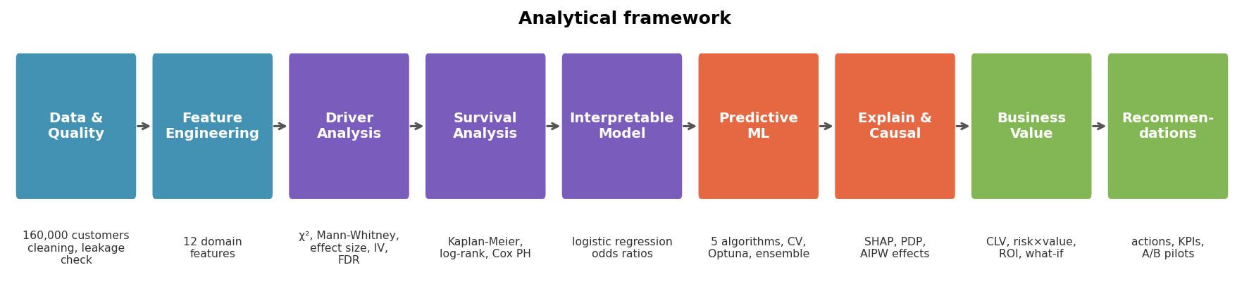
Figure 1. Analytical framework.
All performance figures are out-of-fold estimates with bootstrap 95% confidence intervals. Two sanity checks support the validity of the pipeline: a model trained on shuffled labels scores an AUC of about 0.5, and an adversarial classifier cannot distinguish the training data from the scoring data, so cross-validated performance should carry over to new customers.

3. Findings

3.1 Who churns? Tenure dominates every other factor (RQ1)
Of all variables, tenure is by far the strongest correlate of churn (Information Value 0.93, Cramér's V 0.39). Customers in their first six months churn at 49.2%, compared with 6.9% for customers with two to five years of tenure (Figure 2). Age has a much smaller, monotonic effect: churn falls from 13.9% among 25–34-year-olds to 8.0% among customers aged 65 and over (IV 0.04). Socio-economic variables — income, home value, home ownership, credit standing and even the premium amount — show statistically detectable but practically negligible differences (IV < 0.02), a reminder that with 160,000 records significance alone is not evidence of importance.
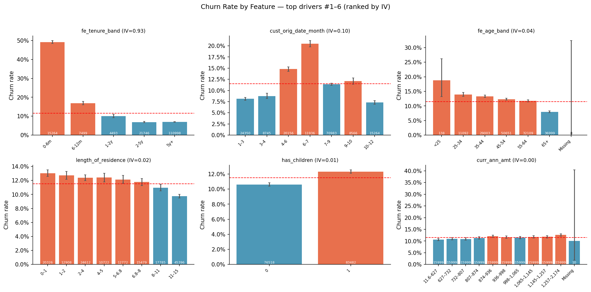
Figure 2. Churn rate by the strongest drivers (bars: churn rate with 95% CI; dashed line: overall churn rate; numbers: customers per group).
Table 1. Evidence for churn drivers across methods (overall churn rate 11.5%).
Driver | Riskiest group | Churn rate | IV | Odds ratio | Hazard ratio | SHAP rank
Tenure (band) | 0–6 months | 49.2% | 0.93 | 12.6 (vs 5y+) | — | #1
Age (band) | 25–34 | 13.9% | 0.04 | 0.88 (65+ vs 45–54) | 2.02 (25–34) | #7
Length of residence | ≤ 1 year | 13.0% | 0.02 | — | — | #4
Has children | Yes | 12.3% | 0.007 | — | — | #6
Annual premium | Top decile | 12.6% | 0.003 | — | — | #14

The multivariate model confirms that the tenure effect is not an artefact of other characteristics. Holding age and the other variables constant, customers in their first six months have 12.6 times the odds of churning of customers with five or more years (95% CI 12.1–13.2), and the effect fades steadily with time: odds ratios of 2.8 for 6–12 months and 1.5 for one to two years. Expressed as an average marginal effect, being a new customer raises the probability of churning by 22 percentage points.

3.2 When do customers churn? A critical window between day 90 and day 180 (RQ2)
Survival analysis sharpens this picture. The Kaplan–Meier estimate shows that 98.6% of customers remain after 90 days, 95.2% after 180 days and 94.3% after one year, after which the curve flattens. The monthly churn hazard (Figure 3) reaches 1.17% per 30 days between day 90 and day 180 — more than double the 0.48% of the first 90 days and about 12 times the average of 0.10%. A concentration of exits around the fourth to sixth month is consistent with the end of a first short policy term and with evidence that lapse declines with contract age (Eling & Kiesenbauer, 2014). The practical implication is that the company has roughly three months after acquisition to secure the relationship.
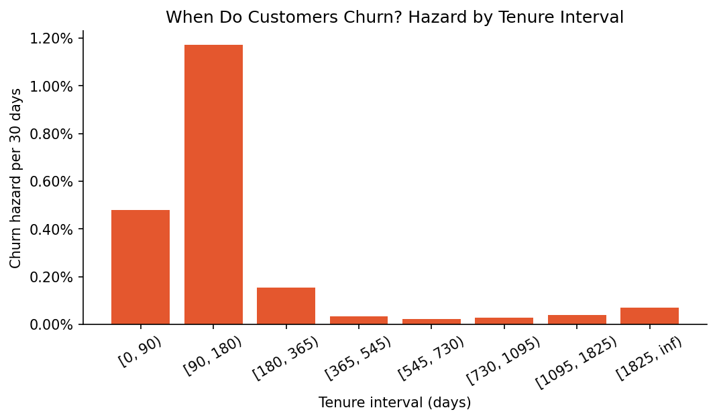
Figure 3. Churn hazard per 30 days by tenure interval: risk is concentrated in days 90–180.
Survival also differs by age (log-rank χ² = 2,932, p < 0.001). In the Cox model, customers aged 25–34 face a 2.0-fold churn hazard relative to 45–54-year-olds (95% CI 1.82–2.23), while customers aged 65 and over face less than half the hazard (HR 0.44).

3.3 Who is most at risk? Interpretable high-risk segments
Table 2. Highest-risk segments identified by a shallow decision tree.
Segment (decision-tree rule) | Customers | Churn rate | Lift
tenure = 0-6m AND years at residence ≤ 10.50 AND children = 1 AND premium/income ≤ 0.01 | 3,258 | 52.8% | 4.6×
tenure = 0-6m AND years at residence ≤ 10.50 AND children = 1 AND premium/income > 0.01 | 3,403 | 51.0% | 4.4×
tenure = 0-6m AND years at residence ≤ 10.50 AND children = 0 | 4,701 | 48.6% | 4.2×
tenure = 0-6m AND years at residence > 10.50 | 3,902 | 45.3% | 3.9×

A shallow decision tree translates these effects into segments that operations teams can act on (Table 2). Every high-risk segment is a new-customer segment: new customers who have lived at their address for at most ten years churn at around 49–53%, more than four times the average. Among established customers no segment exceeds the average churn rate by a meaningful margin, which means retention resources should be concentrated on the beginning of the relationship.

3.4 How well can churn be predicted? (RQ3)
Table 3. Out-of-fold model performance (5-fold stratified cross-validation; random baseline ROC-AUC 0.500, PR-AUC 0.115).
Model | ROC-AUC | PR-AUC | Log-loss
Final ensemble (mean of top 3) | 0.706 | 0.337 | 0.301
LightGBM | 0.705 | 0.336 | 0.301
LightGBM (multi-seed) | 0.704 | 0.334 | 0.302
XGBoost (tuned) | 0.704 | 0.335 | 0.302
LightGBM (tuned) | 0.703 | 0.332 | 0.311
Hist. gradient boosting | 0.703 | 0.334 | 0.301
Logistic regression | 0.703 | 0.333 | 0.305

The final ensemble reaches an out-of-fold ROC-AUC of 0.706 (95% CI 0.701–0.710) and a PR-AUC of 0.337, about 2.9 times the random baseline (Table 3). The ensemble is not significantly better than the interpretable logistic regression (ΔAUC = +0.003, 95% CI -0.001 to +0.006); the small gap shows that most of the signal is captured by a few, largely monotonic effects, which makes the results easy to explain. Discrimination is moderate overall because demographic data cannot reveal many reasons for leaving, but it is very strong where it matters: the top-scored decile churns at 50.0% against 6.9% in the bottom decile, and targeting the top 20% captures 52% of all churners, a 2.6-fold lift over random selection (Figure 4).
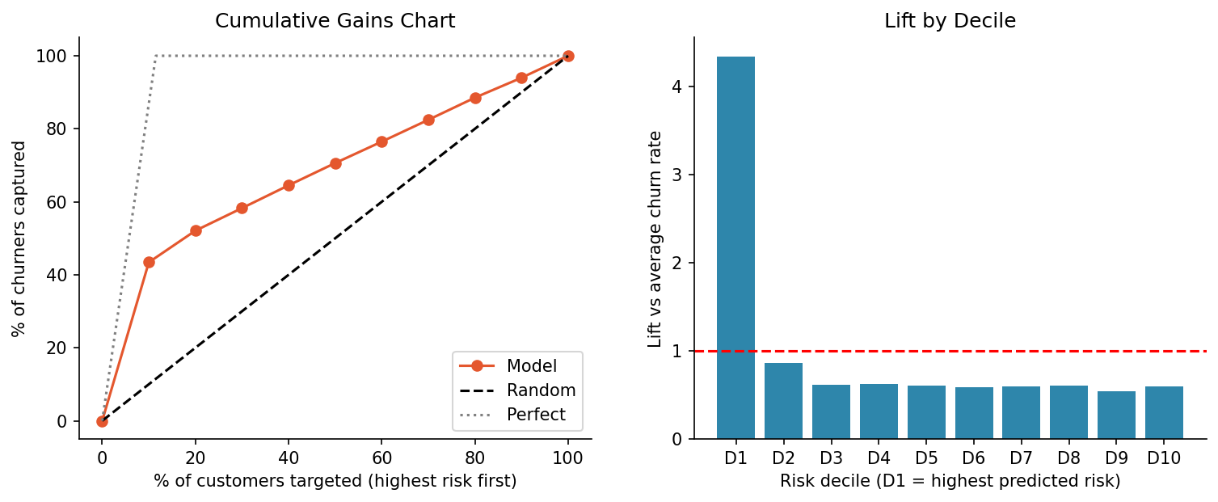
Figure 4. Cumulative gains and lift by risk decile.
SHAP analysis confirms the statistical picture: tenure-related features account for 62% of the model's attributions, with length of residence, age and the premium-to-income ratio contributing modestly. The model therefore behaves as a lifecycle model — it recognises who is new and therefore vulnerable — which is both intuitive for managers and stable across customer groups (the driver ranking is almost identical for married and single customers).

4. Business Impact and Recommendations (RQ4)

4.1 Value at risk and prioritisation
Weighting each customer's churn probability by annual premium, about USD 17.50 million of annual premium (11.5% of the premium base) is expected to be lost. The highest-risk 20% of customers churn at 30.0% and contain 52% of all churners. Crossing risk with value (Figure 5) identifies a 'Priority Save' group — 10% of customers with high risk and above-median premium — that holds 32% of the value at risk and should receive personal contact; high-risk, low-value customers can be served through automated digital touchpoints.
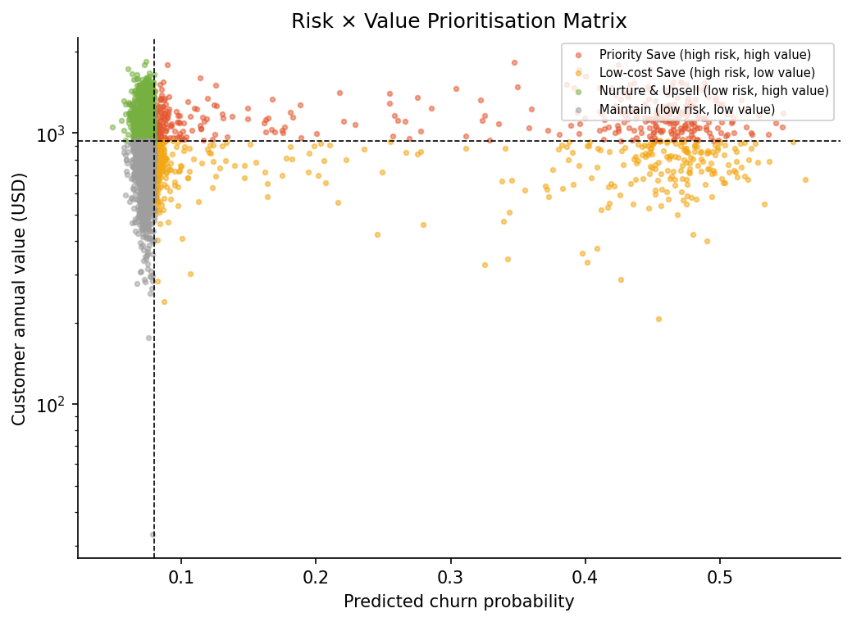
Figure 5. Risk × value matrix: 'Priority Save' customers combine high churn risk with above-median premium.

4.2 Retention campaign economics
We simulated a retention campaign on the out-of-fold predictions, assuming a contact-and-incentive cost of USD 25 per customer, that 25% of contacted would-be churners are retained, and a 15% margin on premium over the customer's expected remaining lifetime. Ranking customers by expected loss (churn probability × value) and contacting the top 10% maximises net benefit at USD 601 thousand (ROI 1.5×), while random targeting is unprofitable at every campaign size (Figure 6). The conclusion is robust: the campaign remains profitable in 8 of the 9 combinations of success rate (12.5%–37.5%) and cost (USD 12.5–50) we tested, and becomes loss-making only when a low success rate meets a high cost.
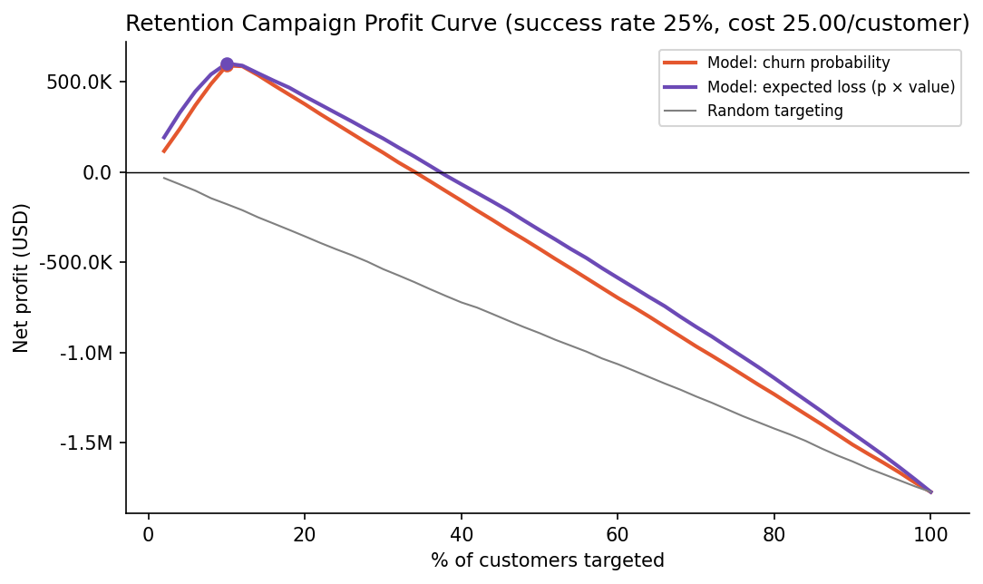
Figure 6. Net profit of a retention campaign by share of customers contacted.

4.3 Recommendations
Table 4. Recommended retention actions.
# | Action | Evidence | What to do | Target | KPI
1 | 180-day onboarding programme | 0–6m churn 49.2%; OR 12.6; hazard peak days 90–180 | Welcome call in week 1, coverage check and app activation in month 1, proactive renewal-readiness contact before day 90, satisfaction check at day 150. | All new customers | 6-month retention; churn in days 90–180
2 | Monthly early-warning score | Top 20% capture 52% of churners; AUC 0.71 | Score all active customers monthly; route Priority Save to retention staff, other high-risk customers to automated digital nudges. | Top 10–20% by expected loss | Retained premium vs control group
3 | Life-stage tailored engagement | 25–34: HR 2.0; 65+: HR 0.44 | Digital-first service, flexible payment and usage-based options for young drivers; loyalty recognition for long-standing older customers. | Customers under 35 | Churn by age band
4 | Measure uplift before scaling | Risk ≠ responsiveness (Ascarza, 2018) | Hold out a random 20% control group in every campaign; use results to train uplift models and re-optimise targeting. | Each campaign | Uplift (treated − control)

The recommendations are sequenced by speed and cost. The onboarding programme and the early-warning score are quick wins that can start within three months using existing contact channels; life-stage offers require product and pricing work over three to six months; and uplift measurement turns each campaign into evidence for the next. Because churn is concentrated in a short, predictable window, a modest budget focused on the first 180 days is likely to deliver more retained value than broad loyalty discounts across the whole book.

5. Conclusion and Limitations
Churn at this insurer is primarily a lifecycle phenomenon. New customers churn at more than four times the average rate (RQ1), the risk concentrates between day 90 and day 180 (RQ2), and a validated ensemble (AUC 0.706) can place 52% of future churners in the top fifth of a ranked list (RQ3). Concentrating retention effort on onboarding and on high-value, high-risk customers yields a positive and robust expected return (RQ4).
The study has limitations. The data are a cross-sectional snapshot from one insurer and contain no information on prices, claims, service contacts or competitor offers, which are known drivers of non-renewal (Brockett et al., 2008; Guelman & Guillén, 2014); the associations reported here are therefore not causal, and the campaign economics rely on assumed costs and success rates. Adding renewal price changes, claims and complaint histories, and running a randomised pilot of the onboarding programme, would allow the insurer to estimate true intervention effects and to target customers by expected uplift rather than risk alone (Ascarza, 2018).

References
Ascarza, E. (2018). Retention futility: Targeting high-risk customers might be ineffective. Journal of Marketing Research, 55(1), 80–98. https://doi.org/10.1509/jmr.16.0163
Benjamini, Y., & Hochberg, Y. (1995). Controlling the false discovery rate: A practical and powerful approach to multiple testing. Journal of the Royal Statistical Society: Series B, 57(1), 289–300. https://doi.org/10.1111/j.2517-6161.1995.tb02031.x
Brockett, P. L., Golden, L. L., Guillén, M., Nielsen, J. P., Parner, J., & Pérez-Marín, A. M. (2008). Survival analysis of a household portfolio of insurance policies: How much time do you have to stop total customer defection? Journal of Risk and Insurance, 75(3), 713–737. https://doi.org/10.1111/j.1539-6975.2008.00281.x
Cox, D. R. (1972). Regression models and life-tables. Journal of the Royal Statistical Society: Series B, 34(2), 187–202. https://doi.org/10.1111/j.2517-6161.1972.tb00899.x
Eling, M., & Kiesenbauer, D. (2014). What policy features determine life insurance lapse? An analysis of the German market. Journal of Risk and Insurance, 81(2), 241–269. https://doi.org/10.1111/j.1539-6975.2012.01504.x
Guelman, L., & Guillén, M. (2014). A causal inference approach to measure price elasticity in automobile insurance. Expert Systems with Applications, 41(2), 387–396. https://doi.org/10.1016/j.eswa.2013.07.059
Kaplan, E. L., & Meier, P. (1958). Nonparametric estimation from incomplete observations. Journal of the American Statistical Association, 53(282), 457–481. https://doi.org/10.1080/01621459.1958.10501452
Lundberg, S. M., & Lee, S.-I. (2017). A unified approach to interpreting model predictions. In Advances in Neural Information Processing Systems 30.
Reichheld, F. F., & Sasser, W. E., Jr. (1990). Zero defections: Quality comes to services. Harvard Business Review, 68(5), 105–111.
Siddiqi, N. (2006). Credit risk scorecards: Developing and implementing intelligent credit scoring. John Wiley & Sons.
Verbeke, W., Dejaeger, K., Martens, D., Hur, J., & Baesens, B. (2012). New insights into churn prediction in the telecommunication sector: A profit driven data mining approach. European Journal of Operational Research, 218(1), 211–229. https://doi.org/10.1016/j.ejor.2011.09.031
Data source: Auto Insurance Churn Analysis Dataset (Kaggle, merishnasuwal). Analysis performed in Python; code provided in the attached notebook.

Appendix (not counted in the page limit)
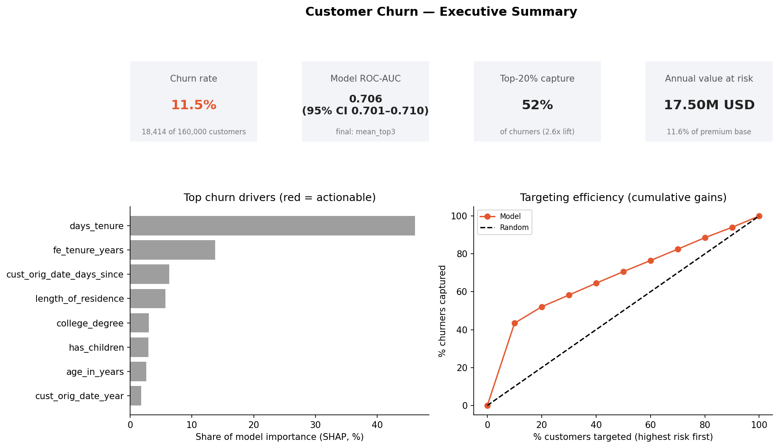
Figure 7. Executive summary dashboard.
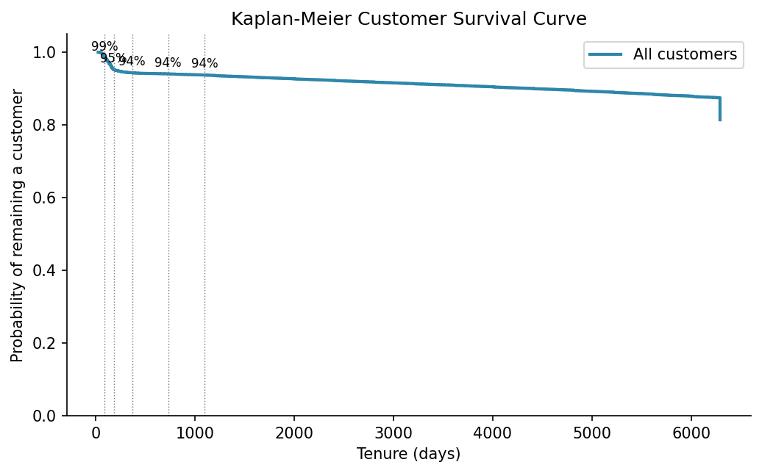
Figure 8. Kaplan–Meier survival curve.
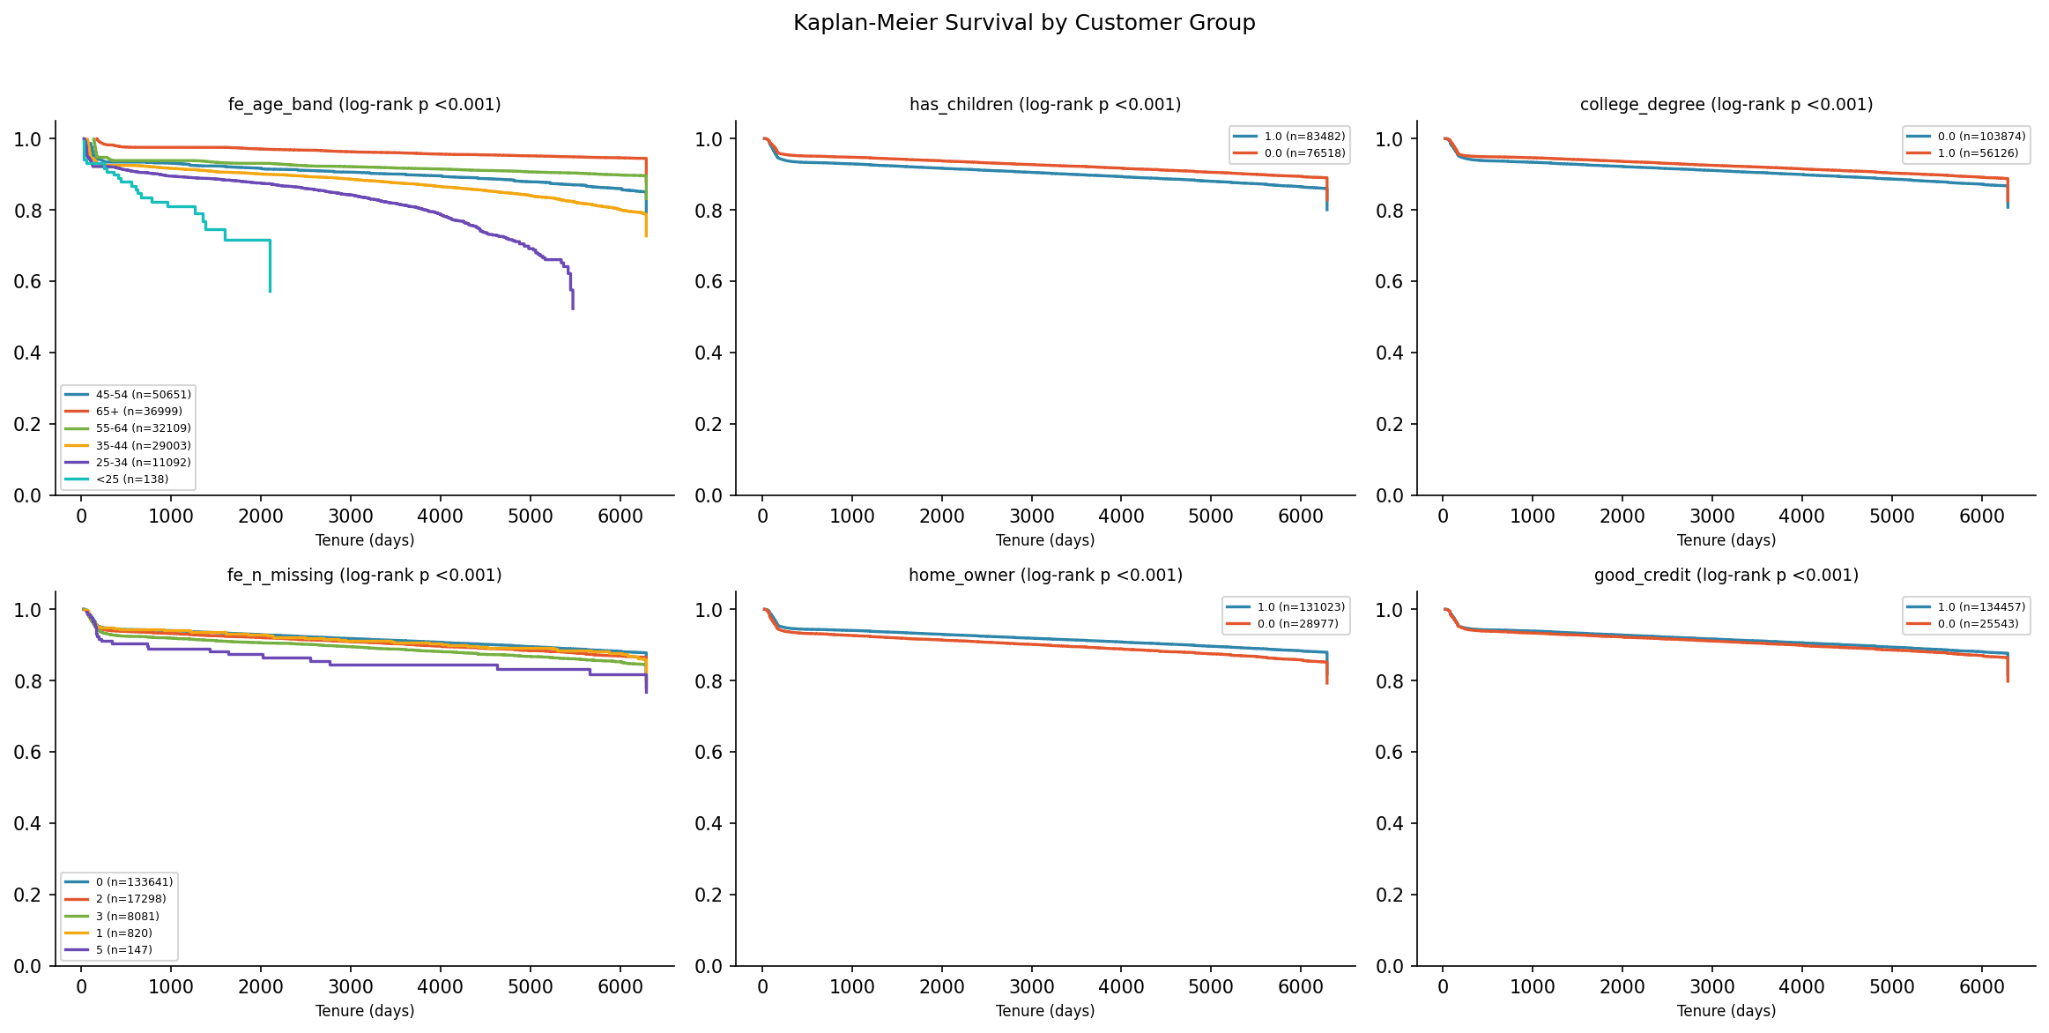
Figure 9. Kaplan–Meier curves by customer group.
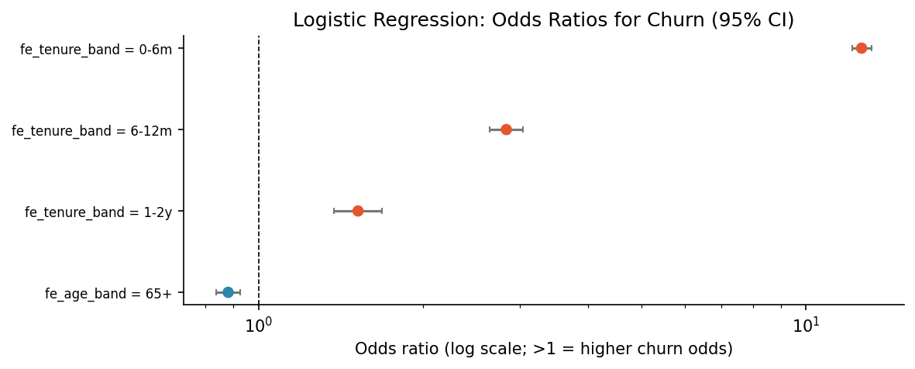
Figure 10. Logistic regression odds ratios (95% CI).
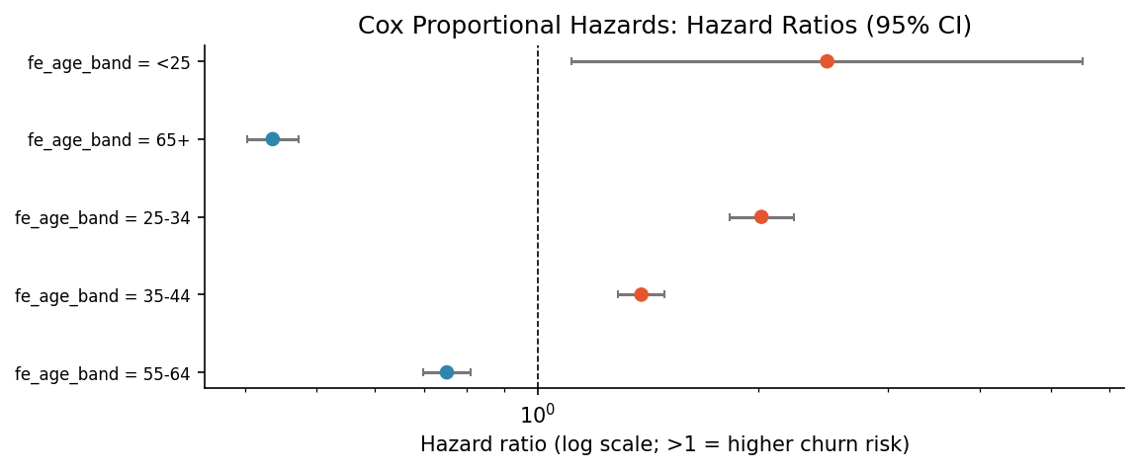
Figure 11. Cox hazard ratios for age bands (95% CI).
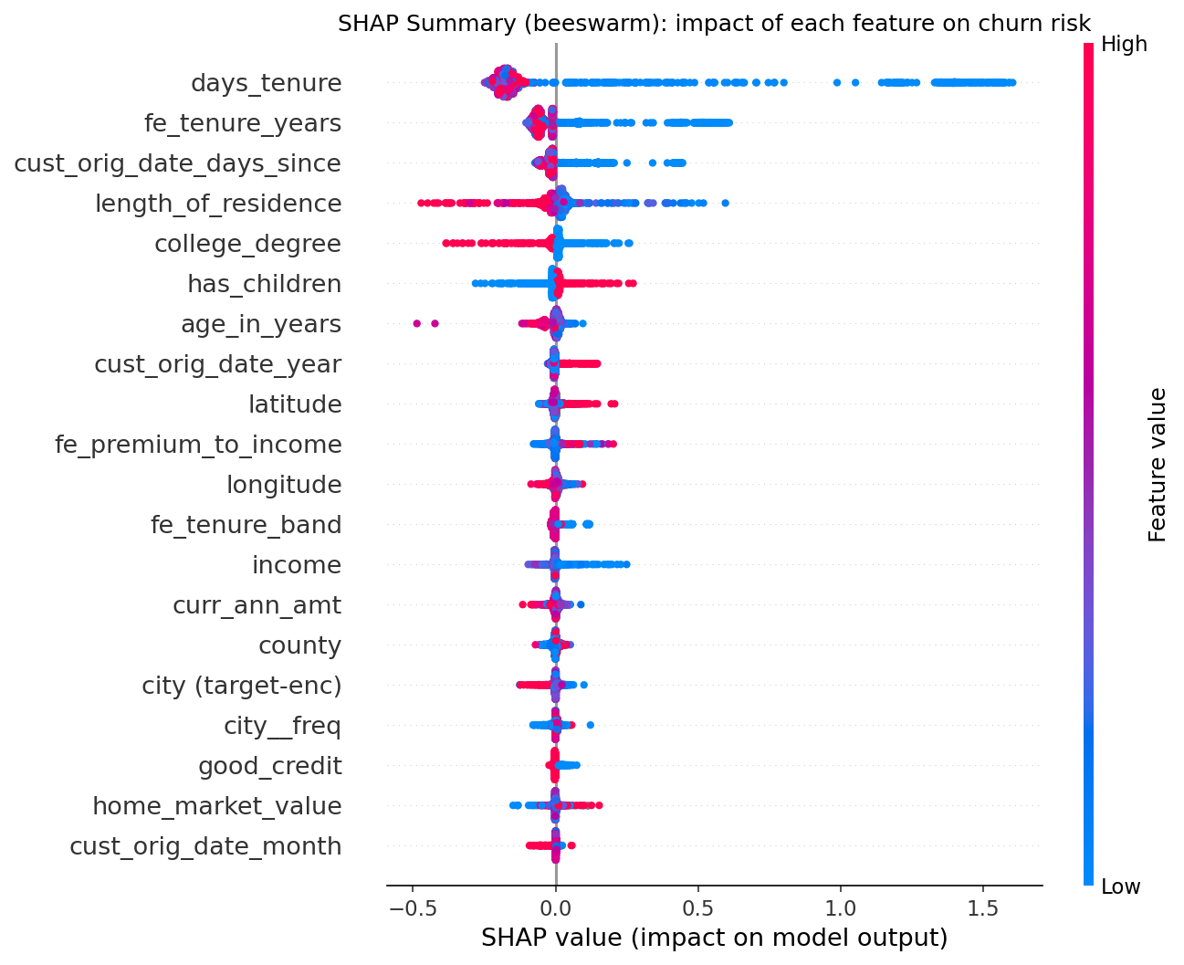
Figure 12. SHAP summary of the final model.
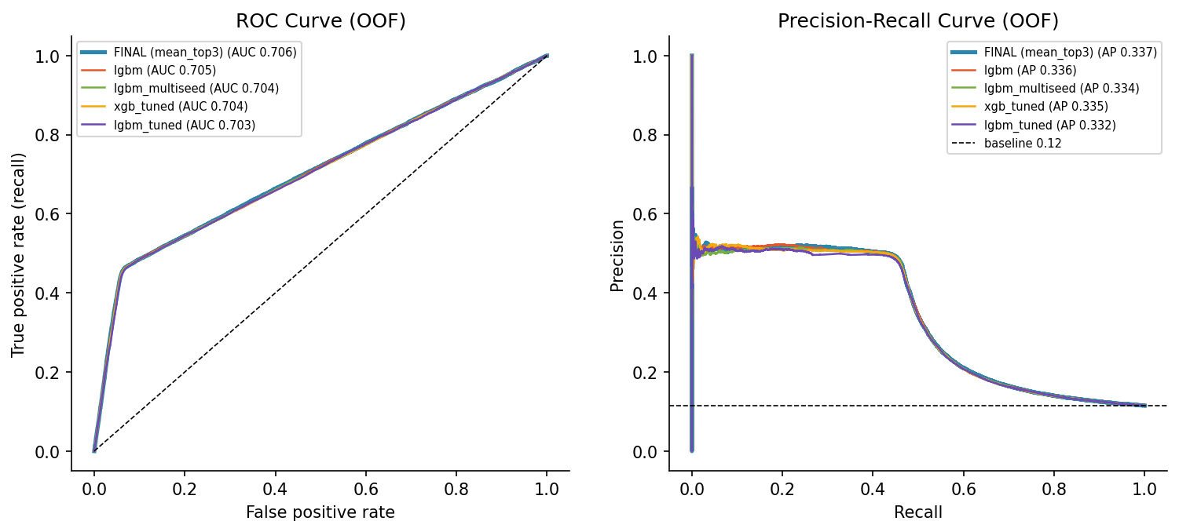
Figure 13. ROC and precision–recall curves.
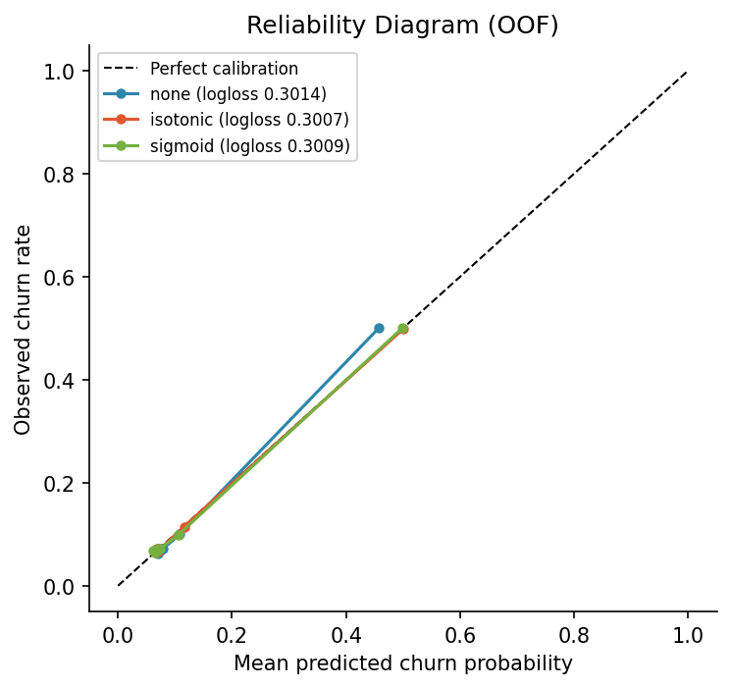
Figure 14. Calibration of predicted probabilities.
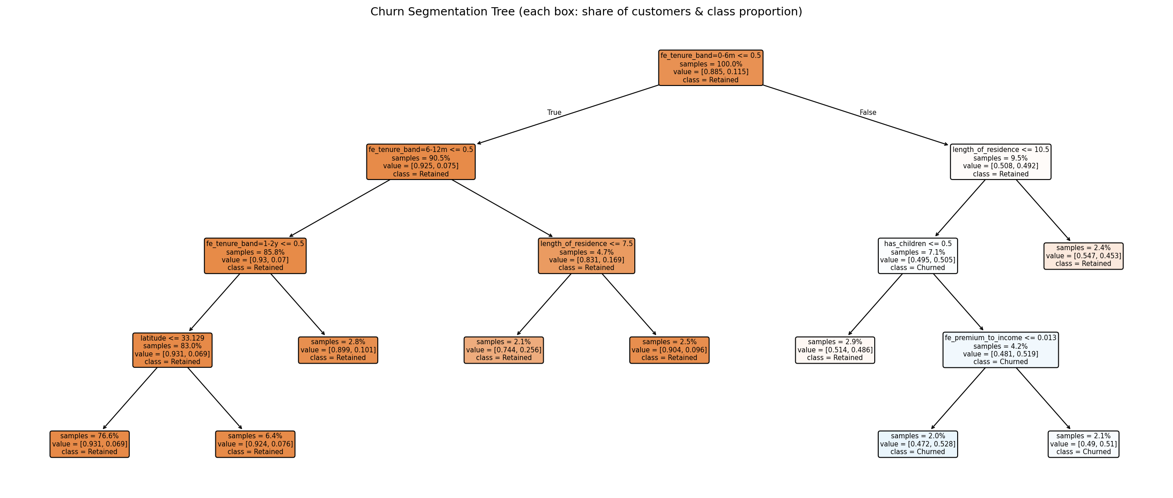
Figure 15. Segmentation tree.
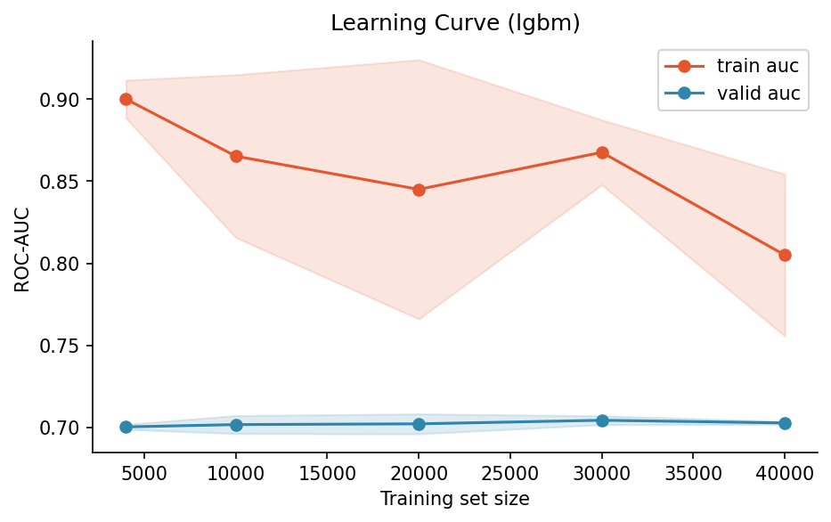
Figure 16. Learning curve.

